Step9.

**JavaScript Functions**  
  
A JavaScript **function**is a block of code designed to perform a particular task.  
The main advantages of using functions:  
Code **reuse**: Define the code once, and use it many times.  
Use the same code many times with different **arguments**, to produce different results.

A JavaScript function is executed when "something" invokes, or calls, it.

**Defining a Function**

To define a JavaScript function, use the **function**keyword, followed by a **name**, followed by a set of **parentheses ()**.  
  
The code to be executed by the function is placed inside curly brackets {}.

**function** name() {   
//code to be executed   
}

Function names can contain letters, digits, underscores, and dollar signs (same rules as variables).

**Calling a Function**

To execute the function, you need to call it.  
To call a function, start with the name of the function, then follow it with the arguments in parentheses.

**Example:**

function **myFunction**() {   
alert("Calling a Function!");   
}   
  
**myFunction**();

Always remember to end the statement with a **semicolon (точка с запятой)**after calling the function.

**Calling Functions**

Once the function is defined, JavaScript allows you to call it as many times as you want to.

function myFunction() {   
alert("Alert box!");   
}   
  
myFunction();   
//"Alert box!"   
  
// some other code   
  
myFunction();   
//"Alert box!"

You can also call a function using this syntax: myFunction.call(). The difference is that when calling in this way, you're passing the 'this' keyword to a function. You'll learn about it later.

**Function Parameters**

Functions can take **parameters**.  
Function **parameters**are the names listed in the function's definition.  
 **Syntax:**

functionName (param1, param2, param3) {   
// some code   
}

As with variables, parameters should be given **names**, which are **separated by commas** within the parentheses.

**Using Parameters**  
After defining the parameters, you can use them inside the function.

function sayHello(name) {   
alert("Hi, " + name);   
}   
sayHello("David");

This function takes in one parameter, which is called **name**. When calling the function, provide the parameter's value (argument) inside the parentheses.

Function **arguments**are the real values passed to (and received by) the function.

# Function Parameters

You can define a single function, and pass different parameter values (arguments) to it.

function sayHello(name) {   
alert("Hi, " + name);   
}   
sayHello("**David**");   
sayHello("**Sarah**");   
sayHello("**John**");

This will execute the function's code each time for the provided argument.

# Multiple Parameters

You can define multiple parameters for a function by **comma-separating** (разделяющий запятую ) them.

function myFunc(x, y) {   
// some code   
}

The example above defines the function **myFunc**to take two parameters.

The parameters are used within the function's definition.

function sayHello(**name**, **age**) {   
document.write( **name** + " is " + **age** + " years old.");   
}

Function parameters are the names listed in the function definition.

When calling the function, provide the arguments in the same order in which you defined them.

function sayHello(name, age) {   
document.write( name + " is " + age + " years old.");   
}   
  
sayHello(**"John", 20**)

If you pass more arguments than are defined, they will be assigned to an array called arguments. They can be used like this: arguments[0], arguments[1], etc.

After defining the function, you can call it as many times as needed.  
JavaScript functions do not check the number of arguments received.

If a function is called with missing arguments (fewer than declared), the missing values are set to **undefined**, whichindicates that a variable has not been assigned a value.

После определения функции вы можете вызывать ее столько раз, сколько потребуется. Функции JavaScript не проверяют количество полученных аргументов.

Если функция вызывается с отсутствующими аргументами (меньше, чем объявлено), отсутствующим значениям присваивается значение undefined, что указывает на то, что переменной не было присвоено значение.

# Function Return (Рекурсивные функции)

A function can have an optional **return**statement. It is used to return a value from the function.  
  
This statement is useful when making calculations that require a result.

When JavaScript reaches a **return**statement, the function stops executing.

Use the **return**statement to return a value.  
  
For example, let's calculate the product of two numbers, and return the result.

function myFunction(a, b) {   
**return** a * b;   
}   
var x = myFunction(5, 6);   
// Return value will end up in x

If you do not return anything from a function, it will return **undefined**.

**Another example:**

function addNumbers(a, b) {   
var c = a+b;   
**return c;**  
}   
document.write (addNumbers(40, 2) );

The document.write command outputs the value returned by the function, which is the sum of the two parameters.

# The Alert Box

JavaScript offers three types of popup boxes, the **Alert**, **Prompt**, and **Confirm**boxes.

## **Alert Box**

An**alert box** is used when you want to ensure that information gets through to the user.  
When an alert box pops up, the user must click OK to proceed.  
The **alert**function takes a single parameter, which is the text displayed in the popup box.

Окно предупреждения используется, когда вы хотите убедиться, что информация доходит до пользователя. Когда появится окно предупреждения, пользователь должен нажать кнопку ОК, чтобы продолжить.

Функция оповещения принимает один параметр, который представляет собой текст, отображаемый во всплывающем окне.

**Example:**

**Alert** ("Do you really want to leave this page?");

**Result:**

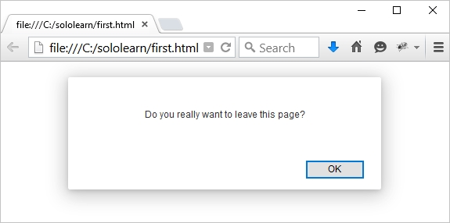

To display **line breaks** within a popup box, use a backslash followed by the character n.

Alert ("Hello**\n**How are you**?”); // Перенос на новую строку!!!**

**Result:**

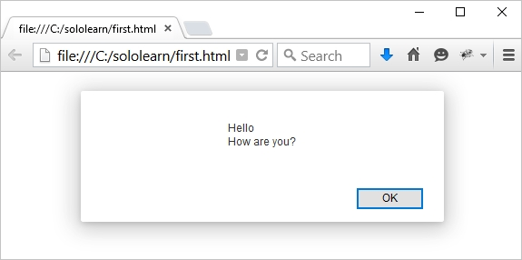

Be careful when using alert boxes, as the user can continue using the page only after clicking OK.

# Prompt Box

A **prompt box** is often used to have the user input a value before entering a page.  
When a prompt box pops up, the user will have to click either OK or Cancel to proceed after entering the input value.  
If the user clicks OK, the box**returns the input value**. If the user clicks Cancel, the box returns **null**.  
  
The **prompt()** method takes **two parameters**.  
- The first is the label, which you want to display in the text box.  
- The second is a default string to display in the text box (optional).

Поле запроса часто используется для того, чтобы пользователь вводил значение перед входом на страницу. Когда появится окно с приглашением, пользователю нужно будет нажать либо OK, либо Cancel, чтобы продолжить после ввода входного значения.

Если пользователь нажимает кнопку ОК, поле возвращает введенное значение. Если пользователь нажимает кнопку Отмена, поле возвращает значение null.

Метод prompt() принимает два параметра.

- Первый - это метка, которую вы хотите отобразить в текстовом поле.

- Вторая строка - это строка по умолчанию для отображения в текстовом поле (необязательно).  
  
**Example:**

var user = prompt ("Please enter your name");   
alert (user);

**The prompt appears as:**

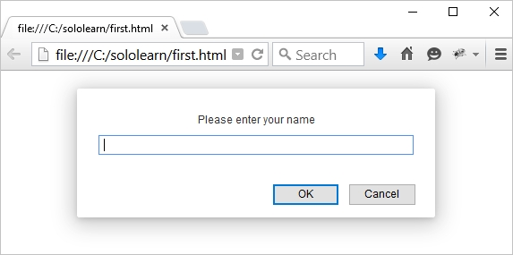

When a prompt box pops up, the user will have to click either "OK" or "Cancel" to proceed after entering an input value. Do not overuse this method, because it prevents the user from accessing other parts of the page until the box is closed.